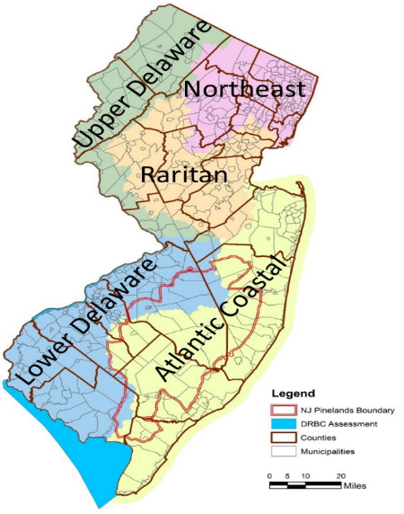

2018/2020 Draft New Jersey Integrated Water Quality Report

Fact Sheet

Purpose
New Jersey’s biennial Integrated Report assesses the health of the state’s waters as required under sections 303(d) and 305(b) of the federal Clean Water Act, the NJ Water Quality Planning Act, and the NJ Water Pollution Control Act.

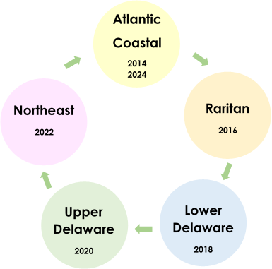
The 303(d) List of Impaired Waters identifies pollutant causes of water quality impairments. The top five causes of impairment include E. coli, biological (cause unknown), arsenic, total phosphorus, and PCBs in fish tissue.
The Integrated Report covers 958 Assessment Units (AUs): over 19,000 miles of rivers and streams, 48,000 acres of lakes, ponds, and reservoirs, 950,000 acres of wetlands, 610 square miles of estuaries, 127 miles of coastline, and 450 square miles of ocean.
Since 2014, NJDEP has employed the rotating regional approach to integrated water quality assessments. In addition to the statewide assessment, this approach includes a comprehensive assessment of one of New Jersey’s five water regions each cycle. The current report combines the 2018 and 2020 reports and focuses on the Upper and Lower Delaware Water Regions.
This rotating regional approach will result in a comprehensive assessment of the entire State every ten years.

Rotating Basin Approach

New Jersey’s waterbodies provide environmental, public health, recreational, and economic benefits to our citizens.
It is important to regularly analyze whether these benefits are being supported currently and to ensure their protection for decades to come.
The Integrated Report summarizes results of both short-term and long-term water quality analysis. The water quality data generated during a five-year period (2014-2018) provides a “snapshot” of regional water quality conditions over a relatively short period of time along with an overview of statewide water quality conditions.
Long-term trends, including ambient chemical data, macroinvertebrate data, and fish population studies, provide a better indication of changes in water quality over time.

This report provides information on:
- Current water quality conditions
- Water quality trends
- Causes of water quality impairment
- Restoration and protection efforts
- NJDEP Water Programs
The EPA and New Jersey state government will use this information to:
- Determine regulatory, preventative, and restoration priorities
- Identify funding for protecting, restoring, and maintaining waters of the state
A significant increase in data over the last decade:
- Increase from 300,000 data samples used in the 2006 assessment to 3 million data samples used in the 2020 assessment.
- Number of AUs with at least one designated use assessed rose to 97%.
- Unassessed designated uses declined from 38% to 18% of AUs with insufficient data*.
- Number of AUs where all designated uses are assessed rose from 35% to 62%*.

* Does not include fish consumption

STATEWIDE Water Quality Trends Analysis

Key Facts and Findings
- Statewide Long-Term Trends over a 35-year period (1980-2016) show total phosphorus and total nitrogen improving; however, nitrate, total dissolved solids, and chloride show increasing concentrations.
Why?
Since the 1980s, wastewater dischargers have been regionalized and upgraded to secondary treatment, New Jersey’s Pollution Discharge Elimination System (NJPDES) permits have reduced nutrient discharge concentrations, NJDEP nonpoint source pollution programs have been implemented, and local stewardship activities have been targeting nonpoint source pollution.
Ammonia reduction measures implemented at wastewater treatment plants oxidize ammonia to form nitrate, inadvertently resulting in increased nitrate concentrations. Ammonia is much more detrimental to the environment than nitrate because of its uptake of oxygen and its toxicity to aquatic life.
Runoff from urban and agricultural areas, including runoff of road salt used to control ice on roadways, is the likely cause of increased TDS and chloride concentrations over time.

Trends | Statewide
Total Phosphorus
Total Nitrogen
Nitrate
Total Dissolved Solids and Chloride
Biology
Metals and Unionized Ammonia
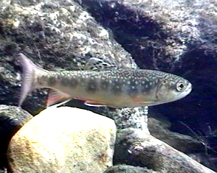
DEP Trend Report
USGS Trend Report
- Statewide metal and ammonia impairments reveal a significant decrease from the 303(d) List since 1998. In the Upper and Lower Delaware Water Regions, 90% of the metal and ammonia impairments have been delisted from the 1998 303(d) List. This does not include arsenic, which continues to be detected at low levels that exceed the human health criteria.
- Statewide biological trends for macroinvertebrates and fish communities show stable conditions, but the trends vary by water region. The Upper Delaware is exhibiting improving biological conditions, while the Lower Delaware is experiencing a decrease in the health of the community.
NJDEP over the last 50 years has been entrusted to protect and restore our precious resources by preventing pollution, cleaning up contamination, ensuring ample water supply and investing in strong infrastructure. Numerous programs within NJDEP are designed to protect, maintain, enhance, and restore water quality through the implementation of regulatory and non-regulatory actions. These actions include developing Total Maximum Daily Loads, issuing permits to upgraded wastewater dischargers, regulating stormwater, implementing land use management programs, providing restoration grants, managing nonpoint agricultural runoff, granting financial assistance for infrastructure construction, acquiring land, educating the community, protecting wetlands, controlling air quality, and enforcing compliance of water regulations. The progress exhibited by NJDEP’s water quality management programs is supported by the results of the Water Quality Trends Analysis, which shows improving and stabilizing conditions for key parameters over time.

New Jersey Water Quality Trends at a Glance

Stable
Increasing Concentration
Decreasing Concentration
Designated Use | Description | Actions
Aquatic Life (General) | Can these waters support a healthy ecosystem? Monitoring focuses on determining excessive nutrients and impaired biological communities which are the primary causes of designated use impairment. | Water Quality Restoration Grants for Nonpoint Source Pollution are made available annually to help improve water quality due to excessive nutrients.
Aquatic Life (Trout) | Can species of trout survive and reproduce in these waters? These waterbodies are monitored for meeting dissolved oxygen and cold-water temperature ranges capable of supporting trout species. | Trout Production waters are eligible for Category One Designation and thus protected from any measurable change in water quality.
Recreation | Can we swim, boat, and do other activities in these waters? Three bacterial indicators that are monitored and tested to determine recreational use are fecal coliform, E. coli, and Enterococcus. | TMDLs to identify and reduce pollutant loads to meet surface water quality standards have been established for 73% of impaired waters.
Water Supply | Can we use these waters as sources for drinking water? Ambient water quality is monitored in rivers and lakes for chemical pollutants, metals, and toxins before undergoing treatment to be used as a water supply. | Water supplies are protected by the NJ Safe Drinking Water Act and NJ Water Supply Plan by establishing standards, conducting monitoring, completing inspections, and resolving violations.
Shellfish Harvest | Can we eat clams, oysters or mussels from these waters? NJDEP monitors fecal coliform levels and the bacterial species Vibrio parahaemolyticus to ensure safe harvests of shellfish. | The Nonpoint Source Tracking Program targets degraded areas by identifying pollutant sources and collaborating with the community to fix the problem.
Fish Consumption | Can we eat fish from these waters? Fish tissue in different species are currently monitored for metals including “legacy” pollutants such as PCB, DDT, and chlordane which are no longer manufactured, but are still found in fish tissue. | NJDEP issues Fish Consumption Advisories and Guides to advise on which fish are safe to eat. An approved Mercury TMDL addresses air emissions to decrease concentrations in fish tissue.

2020 Statewide Designated Use Assessment Results

Overview of Designated Uses
Through the Integrated Report, NJDEP analyzes whether waterbodies are meeting water quality standards by determining if they support a designated use. Designated use descriptions and examples of implemented actions are described below:

